**1. x <- c(‘data.science.in.R’, ‘machine.learning.in.R’)**

**Perform the below string Operation:**

**• Replace the period character "." within each string with another character i.e. "-" minus sign.**

**Ans:**

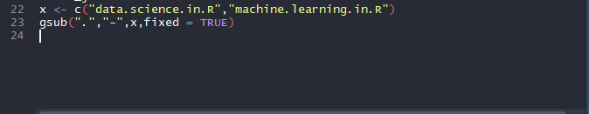

sub(pattern, replacement, x)

gsub(pattern, replacement, x)

Replace the first occurrence of a pattern with sub or replace all occurrences with gsub.

* pattern – A pattern to search for, which is assumed to be a regular expression. Use an additional argument fixed=TRUE to look for a pattern without using regular expressions.
* replacement – A character string to replace the occurrence (or occurrences for gsub) of pattern.
* x – A character vector to search for pattern. Each element will be searched separately.

**2. x <- c('data.science.in.R','machine.learning.in.R') Perform the below String Operation:**

**• Append again with “-“minus sign character at the start of the each string and finally concatenate all the string within the vector to form a final single string and assigning it the object.**

**Ans:**

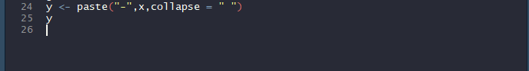

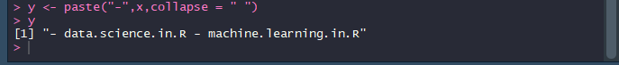

paste can do two things:

concatenate values into one "string", e.g.



where the argument sep specifies the character(s) to be used between the arguments to concatenate, or collapse character vectors.

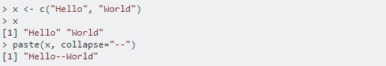

where the argument collapse specifies the character(s) to be used between the elements of the vector to be collapsed.

You can even combine both:

